**Answer question 3.**

**Insert screenshots for questions 5, 8, 12, and 14**

1. Start VMware Player and start an openSUSE virtual machine
2. Open a terminal window and display the last 10 lines of your passwd file by typing **tail/etc/passwd** and pressing Enter. Find the entry for your user account. For instance, for a user logged in as amber, the entry would look like this: *amber:x:1000:100:Amber Dawn:/home/amber:/bin/bash*
3. Try to view the /etc/shadow file by typing **tail /etc/shadow** and pressing Enter. Were you able to view this file? Why? No – Don’t believe this account has privileges to view said folder through the program._________________________________________
4. Type **su** and press Enter, and then enter the root password. To see the last 10 lines of the /etc/shadow file, type **tail /etc/shadow** and press Enter. Find the user you’re currently logged in as and examine the entry for this user account.
5. View the contents of one of your user account configuration files (*login.defs*) by **typing less /etc/login.defs** and pressing Enter. Use the arrow keys (or mouse wheel) to scroll through this file. Find the password aging settings and compare the entries in this file with the information you viewed in Step 4. Which fields in the */etc/shadow* file show the same password-setting information that’s in */etc/login.defs*? When you’re finished examining this file, **insert a screenshot here,** then press q to exit the less command. The information is in the last line of the /shadow command.

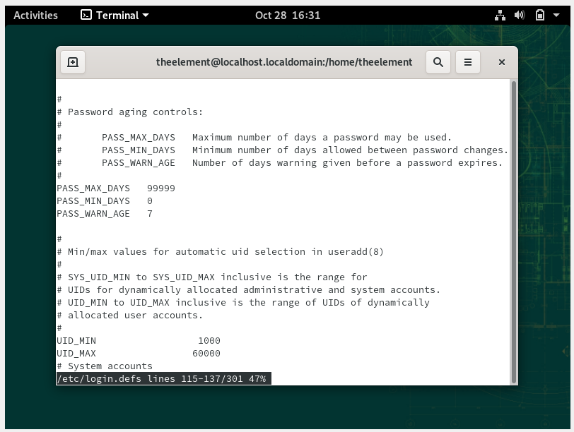

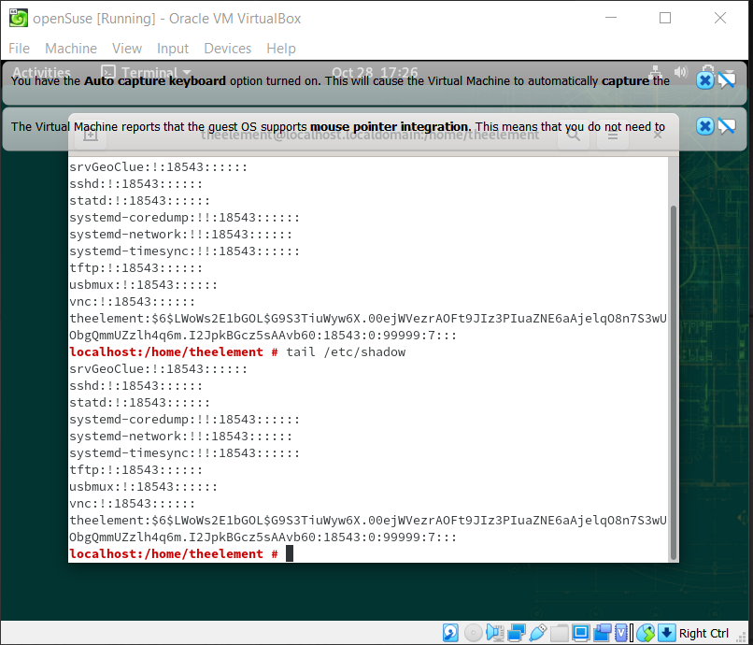

1. The *useradd* file contains basic user account creation information, such as the location of the skeleton directory. To find your skeleton directory, type **cat /etc/default/useradd** and press Enter. In openSUSE, the default skeleton directory is /etc/skel. Change to the skeleton directory by typing **cd /etc/skel** and pressing Enter.
2. Display a long listing of files and subdirectories in your current directory *(/etc/skel*) by typing **ls -l** and pressing Enter. The files and directories you see are the ones copied to a new user’s home directory.
3. Review the options for the useradd command by typing **useradd --help** and pressing Enter. Remember that you must be logged in as root to issue this command. **Insert a screenshot here**

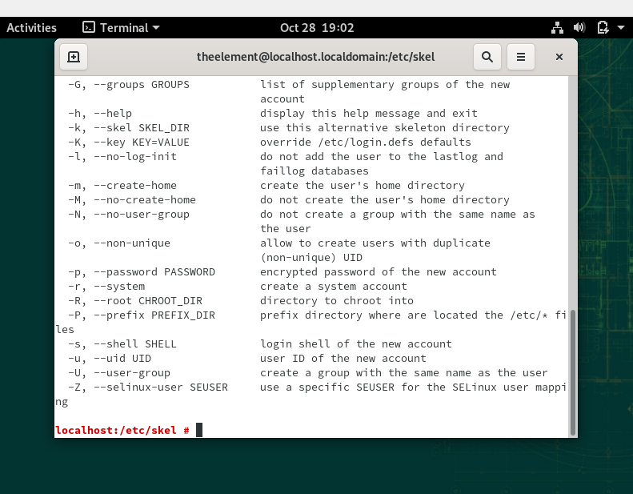

1. Create a user and add a home directory by typing **useradd -m paimon** and pressing Enter.
2. Type **tail /etc/shadow** and press Enter. Find the *paimon* entry and notice that the password field has only the ! symbol, which means the password hasn’t been set for this user.
3. Set the password for *paimon* by typing **passwd paimon** and pressing Enter. Type **EheTeNandayo** as the new password and press Enter, and then enter the password again to confirm.
4. Type **tail /etc/shadow** and press Enter. Find the *paimon* entry, and confirm that the password field now contains a password instead of the ! symbol. (Remember that this password is encrypted.) **Insert a screenshot here**

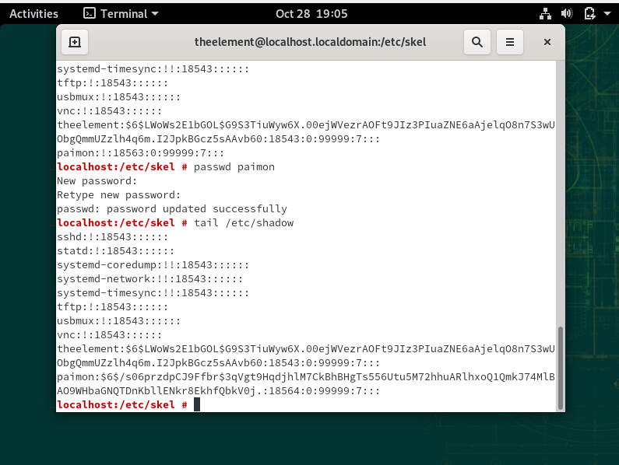

1. Display a long listing of files and subdirectories in *paimon’s* home directory by typing **ls -l** **/home/paimon** and pressing Enter. Compare the results with the results in Step 7.
2. 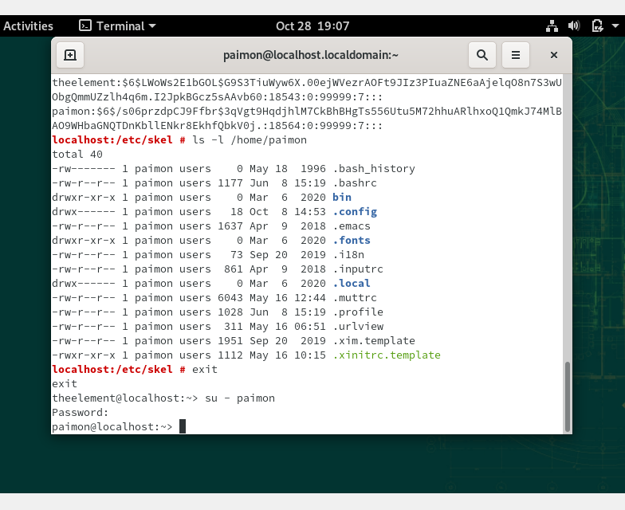Type **exit** and press Enter to exit the root user account. Type **su - paimon** and press Enter to switch to the paimon user account, and then type **EheTeNandayo** as the password and press Enter. **Insert a screenshot here.**